Final Project Report

NLP Chatbot Development using Dialogflow



Project Supervisor
Abdullah Qamar

Submitted By

F24PROJECT38A67
Saleha Shaukat BC230424569

Software Projects & Research Section,
Department of Computer Sciences,
Virtual University of Pakistan


CERTIFICATE

This is to certify that <Saleha Shaukat (BC230424569) have worked on and completed their Software Project at Software & Research Projects Section, Department of Computer Sciences, Virtual University of Pakistan in partial fulfillment of the requirement for the degree of BS in Computer Sciences under my guidance and supervision.

In our opinion, it is satisfactory and up to the mark and therefore fulfills the requirements of BS in Software engineering.

Supervisor / Internal Examiner

Abdullah Qamar
Supervisor,
Software Projects & Research Section,
Department of Computer Sciences
Virtual University of Pakistan

___________________
(Signature)

External Examiner/Subject Specialist
<<External Supervisor Name>>

___________________
(Signature)

Accepted By:

_____________
(For office use)

EXORDIUM

In the name of Allah, the Compassionate, the Merciful.

Praise be to Allah, Lord of Creation,
The Compassionate, the Merciful,
King of Judgment-day!

You alone we worship, and to You alone we pray for help,
Guide us to the straight path

The path of those who You have favored,

Not of those who have incurred Your wrath,
Nor of those who have gone astray.

DEDICATION

Thank to Allah and his beloved Prophet Muhammad (PBUH)

I dedicate this project to my beloved Mother, whose unwavering love and encouragement have been a constant source of inspiration throughout my life. Her selflessness and dedication to my well-being have taught me the true meaning of perseverance and determination. Without her unwavering belief in my abilities, I would not have had the courage to embark on this endeavor and see it through to completion.

ACKNOWLEDGEMENT
I would like to take this opportunity to express my sincere gratitude and appreciation to my supervisor and the University for their invaluable support throughout the completion of this project. Their guidance and resources have been crucial to its successful execution.
First and foremost, I extend my heartfelt thanks to my supervisor for their unwavering commitment and mentorship. Their expertise in the field, constructive feedback, and encouragement were instrumental in shaping the project's direction and enhancing its overall quality. I am grateful for the time they dedicated to discussing ideas, reviewing drafts, and providing valuable insights that pushed me to strive for excellence. I am also deeply thankful to the university for providing an environment conducive to learning and research. I am also grateful to all of person who are directly are indirectly involved in this project and pray for us.
PREFACE
This project has helped me in gaining valuable knowledge to create a functional, secure and user-friendly web application that meets the needs of the Form Creator and Guest users while offering a unique experience. During this phase of learning, this project helped me to enhance my knowledge regarding the work. I have undergone many experiences related to the programming concepts, procedures, views, triggers and many other concepts.

CHAPTER 1
Gathering & Analyzing Info

CHAPTER NO. 1
gathering & Analyzing info 10

1.1 Introduction

This project is focused on developing a chatbot powered by AI for restaurants using Google Dialogflow technology.The chatbot is designed to streamline operations such, as booking tables discussing menu items taking orders and addressing inquiries.This initiative aims to enhance customer satisfaction and optimize restaurant processes. Customers will have the convenience of reserving tables browsing menu choices requesting orders and receiving responses to queries via a platform. Using Natural Language Processing (NLP) technology, the chatbot facilitates communication, reduces wait times, and assists in lightening the workload for restaurant employees.

1.2 purpose

This project focuses on building a conversational interface for restaurant customers using Dialogflow. The scope includes booking tables, showing menu items, and taking orders. It does not include inventory management or kitchen automation.

1.3 scope

The purpose of this project is to develop an AI-powered chatbot specifically for restaurant businesses using Google Dialogflow. The chatbot will act as a virtual assistant, providing functionalities such as making table reservations, navigating the menu, placing food orders, and answering common queries. This system is designed to enhance customer interactions, improve efficiency, and offer greater convenience.
The chatbot will handle key customer requests such as answering frequently asked questions, processing reservation requests, navigating the menu, and assisting with placing orders. By offering quick, conversational responses, it ensures that customers receive timely assistance, thereby improving their overall experience.
However, the system will not address complex order customizations beyond predefined options. It will also exclude payment processing, detailed inventory management, and customer feedback analysis, as these are beyond the scope of this project.

1.4 definitions, acronyms and abbreviations
NLP – Natural Language Processing. A part of AI that helps computers understand and respond to human language.
UI – User Interface. This is the part of the system that users see and interact with, like the chatbot window or website.
UX – User Experience. This means how the user feels while using the system — whether it is easy, smooth, and comfortable to use.
Dialogflow – A tool by Google used to create chatbots that can talk with users in a smart and natural way.
Intent – It shows what the user wants to do. For example, if someone says “I want to book a table,” the intent is “Table Booking.”
Entity – Special information in the user’s message, like time, date, number of people. These help the chatbot understand details.
Webhook – A piece of code written in Python or PHP that connects the chatbot to a database or another system to get or send data.
MySQL – A database system used to store all the important data like orders, bookings, and menu items.
IDE – Integrated Development Environment. This is the software used for writing code, like Visual Studio Code (VS Code).
HTML / CSS / JS – These are used to build the front end of the website. HTML gives the structure, CSS adds the design, and JavaScript makes it interactive.
API – Application Programming Interface. It helps the chatbot talk to other services or databases to get the required information.

1.5 use cases and usage scenarios

1.5.1 Use Case Diagrams
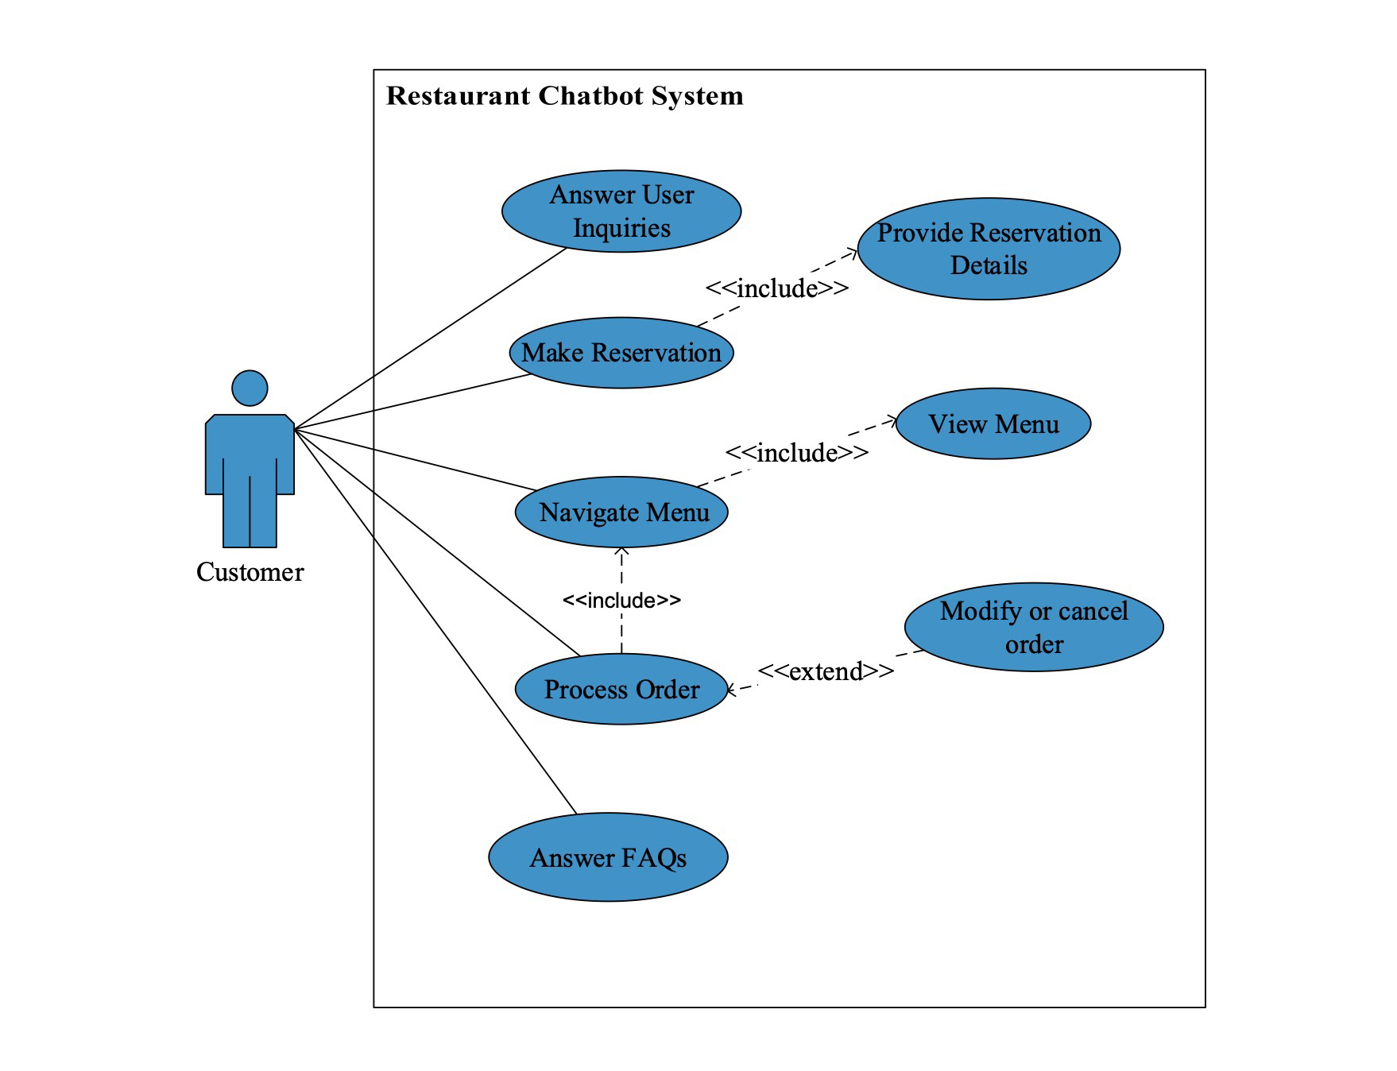

1.5.2 Usage Scenarios

Use Case Title | Handling User Inquiries
Use Case Id | UC-001
Description | The chatbot understands and responds to user queries related to restaurant services.
Action | 1. Customer types a query  2. Chatbot processes the query using NLP.  3. Chatbot provides a relevant response or information.
Alternate Path | If the query is unclear, chatbot requests for clarification.
Pre-Condition | The chatbot must be active and connected to the system, and capable of understanding queries.
Post-Condition | The Customer inquiry is resolved, or they are prompted to ask another question.
Author | Bc230424569
Exception | If Chatbot fails to understand the query and will ask the user to rephrase the question for better understanding.

Use Case Title | Making Reservation
Use Case Id | UC-002
Description | The chatbot allows users to book a table at the restaurant by providing details like date, time, number of people.
Action | 1. Customer enters details( date, time, number of people).  2. Chatbot checks availability and confirms the reservation.
Alternate Path | If the requested time is unavailable, chatbot suggests alternative slots.
Pre-Condition | The Customer must have access to internet so that chatbot must have access to the reservation system .
Post-Condition | The customer receives a confirmation of the reservation with details.
Author | BC230424569
Exception | If the user enters invalid data, the chatbot will prompt for corrections.

Use Case Title | Order Processing
Use Case Id | UC-003
Description | The chatbot processes the customer’s food order by selecting dishes and confirming the details.
Action | 1. Customer selects items from menu  2. Chatbot confirms the selected items and processes the order.
Alternate Path | If items are unavailable, chatbot suggests alternatives.
Pre-Condition | Customer must have access to the menu, and the chatbot must be connected to the order processing system.
Post-Condition | The order is successfully placed and confirmed.
Author | BC230424569
Exception | 1. The order cannot be placed due to system failure or unavailable menu items.  2. The Customer cancels the order before confirmation.

Use Case Title | Answer FAQs
Use Case Id | UC-004
Description | The chatbot answers frequently asked questions about restaurant details like hours, location, and services.
Action | 1. Customer asks question about restaurant details.  2. Chatbot retrieves and provides the required information.
Alternate Path | If the question is not recognized, chatbot asks for more details.
Pre-Condition | The chatbot must be able to recognize and respond to frequently asked questions.
Post-Condition | The customer receives accurate answers to their questions.
Author | BC230424569
Exception | Chatbot fails to retrieve or provide the requested information.

1.6 supplementary requirements

1.6.1 Usability
- Easy to Use: The chatbot should be simple and easy for customers to use, even if they aren’t familiar with technology.

1.6.2 Reliability
- Availability: The chatbot should be available most of the time, meaning it should work most of the time with very little downtime.
- If something goes wrong, the chatbot should give helpful error Functional and non Functional Requirements

1.6.3 Supportability
The system should be easy for developers to update and manage. It should be designed in a modular way, so changes can be made without affecting the whole system. Developers should be able to add new features or update menu items without rewriting code. Configuration settings like restaurant hours or special offers should be easy to change. The system should also support tools like GitHub for version control and updates.

1.6.4 System Requirements

Chatbot Platform:
- Google Dialogflow) – for designing intents, entities, and conversation flows using natural language processing.
Backend Development:
- Python (Flask framework) or PHP – to create webhook services that handle business logic like database operations and dynamic responses.
Frontend Development:
- HTML, CSS, JavaScript – to design the user interface that embeds the chatbot on the website or web app.
Database:
- MySQL – for storing reservation details, order history, and menu data in a structured and retrievable way.
Development Environment:
- Visual Studio Code (VSCode) – recommended code editor for writing and managing project files.

CHAPTER 2
Planning the Project

CHAPTER NO. 2
planning the project 11
2.1 Introduction

Planning is a vital part of software development. It helps the team stay organized and work step by step toward the final goal. This chapter explains the planning strategy for developing the NLP-based chatbot using Google Dialogflow for a restaurant. The planning includes selecting the development methodology, defining the phases, dividing team roles, and setting the schedule.

2.2 Methodology
A software development methodology is a system of practices used to structure, plan, and control the process of developing a project. In this chatbot project, a hybrid approach is used that combines both the Waterfall Model and Incremental Model. This combination ensures proper documentation in early stages and flexibility during development.

  - Available Methodologies
There are many methodologies that can be used for software development:
- Waterfall Model – A linear and sequential approach where each phase is completed before the next one begins.
- Agile Model – A flexible method that allows changes during the development process and promotes quick releases.
- Incremental Model – The system is built in small parts, or increments. Each part adds functionality to the existing system.
- RAD (Rapid Application Development) – Focuses on rapid development with user feedback using prototypes

  - Chosen Methodology
This project uses a hybrid methodology combining the Waterfall and Incremental models:
- The Waterfall model is applied in the early phases (SRS and Design Documents) for proper documentation and approvals.
- The Incremental model is used in the development phases (Prototype and Final Product), allowing improvements and adjustments in small steps.

  - Reasons for Chosen Methodology
This combination ensures:
- Proper structure and clarity at the beginning of the project.
- Easier updates and feedback implementation during development.
- Division of work into phases for better quality control.
- Smoother testing and user-centered design.
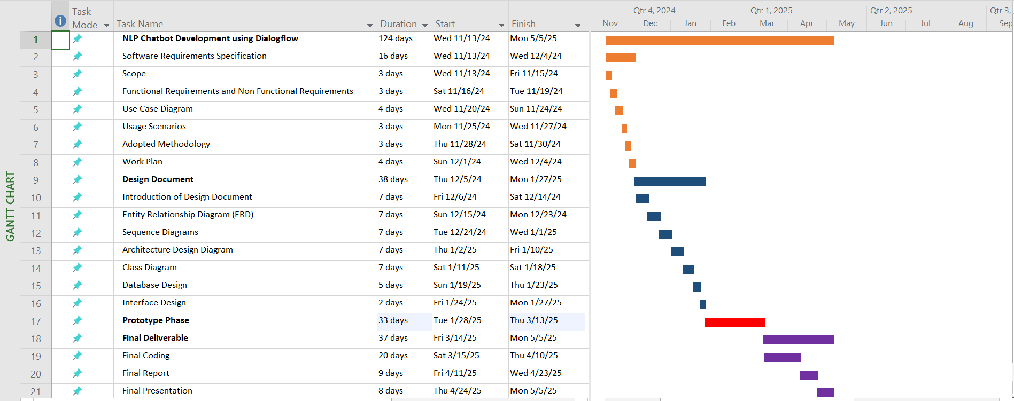

  - Project Structure

    - Team Structure
This project is completed individually, without a team. All responsibilities including planning, development, testing, and documentation are handled by a single person. As the sole developer, I am responsible for gathering requirements, designing chatbot flows in Dialogflow, developing the backend using Python and MySQL, creating the front-end interface, and writing all technical documentation such as the SRS and design documents. Managing the timeline, implementing features, and handling testing are also part of my individual role. The project is completed under the guidance of a supervisor, who reviews each phase and provides feedback when required.

    - Project Schedule (Submission Calendar)

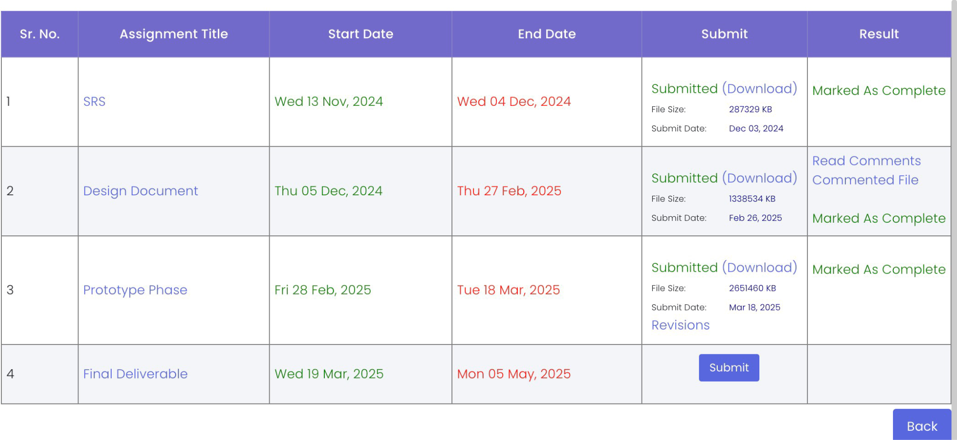

CHAPTER 3
Designing the Project

CHAPTER NO. 3
designing the project 12

3.1 Introduction
After gathering the requirements and preparing the SRS, the next step is to design the system. This chapter presents the design elements of the chatbot project, including diagrams, models, and interfaces. These designs help in understanding how different components will work together and ensure that development follows a clear and structured path.

3.2 purpose

The purpose of this design phase is to create a visual and logical plan for building the chatbot. It ensures that all system parts—including the backend, frontend, and database—are connected properly and function as expected. A strong design saves time during development and helps avoid errors later.

3.3 scope

This design focuses on how the chatbot will interact with users, process their inputs, and store data. It includes user interaction flow (via sequence diagrams), data relationships (via database diagrams), logic structure (via class diagrams), and user interface layouts. The design also shows the connection between Dialogflow, the webhook, and the database.

  - definitions, acronyms and abbreviations

UML – Unified Modeling Language (used for diagrams)
GUI – Graphical User Interface
DB – Database
NLP – Natural Language Processing
API – Application Programming Interface
ERD – Entity Relationship Diagram
Webhook – A backend service triggered by Dialogflow to process logic
Intent – User’s intention in a chatbot message

  - Dynamic Model: Sequence Diagrams
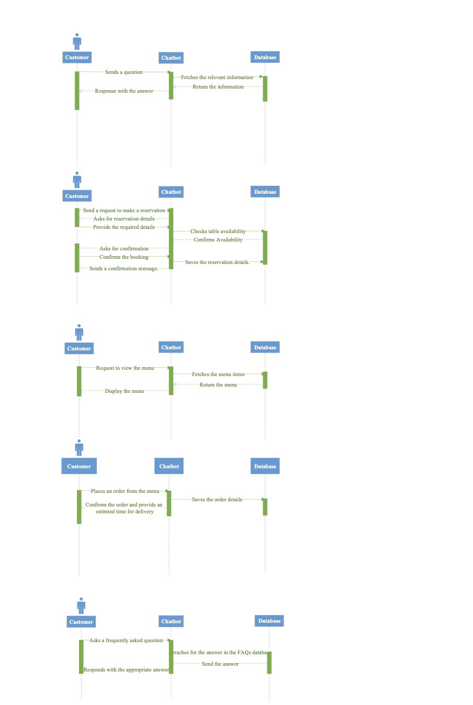

  - Object Model/Logical Model: Class Diagram

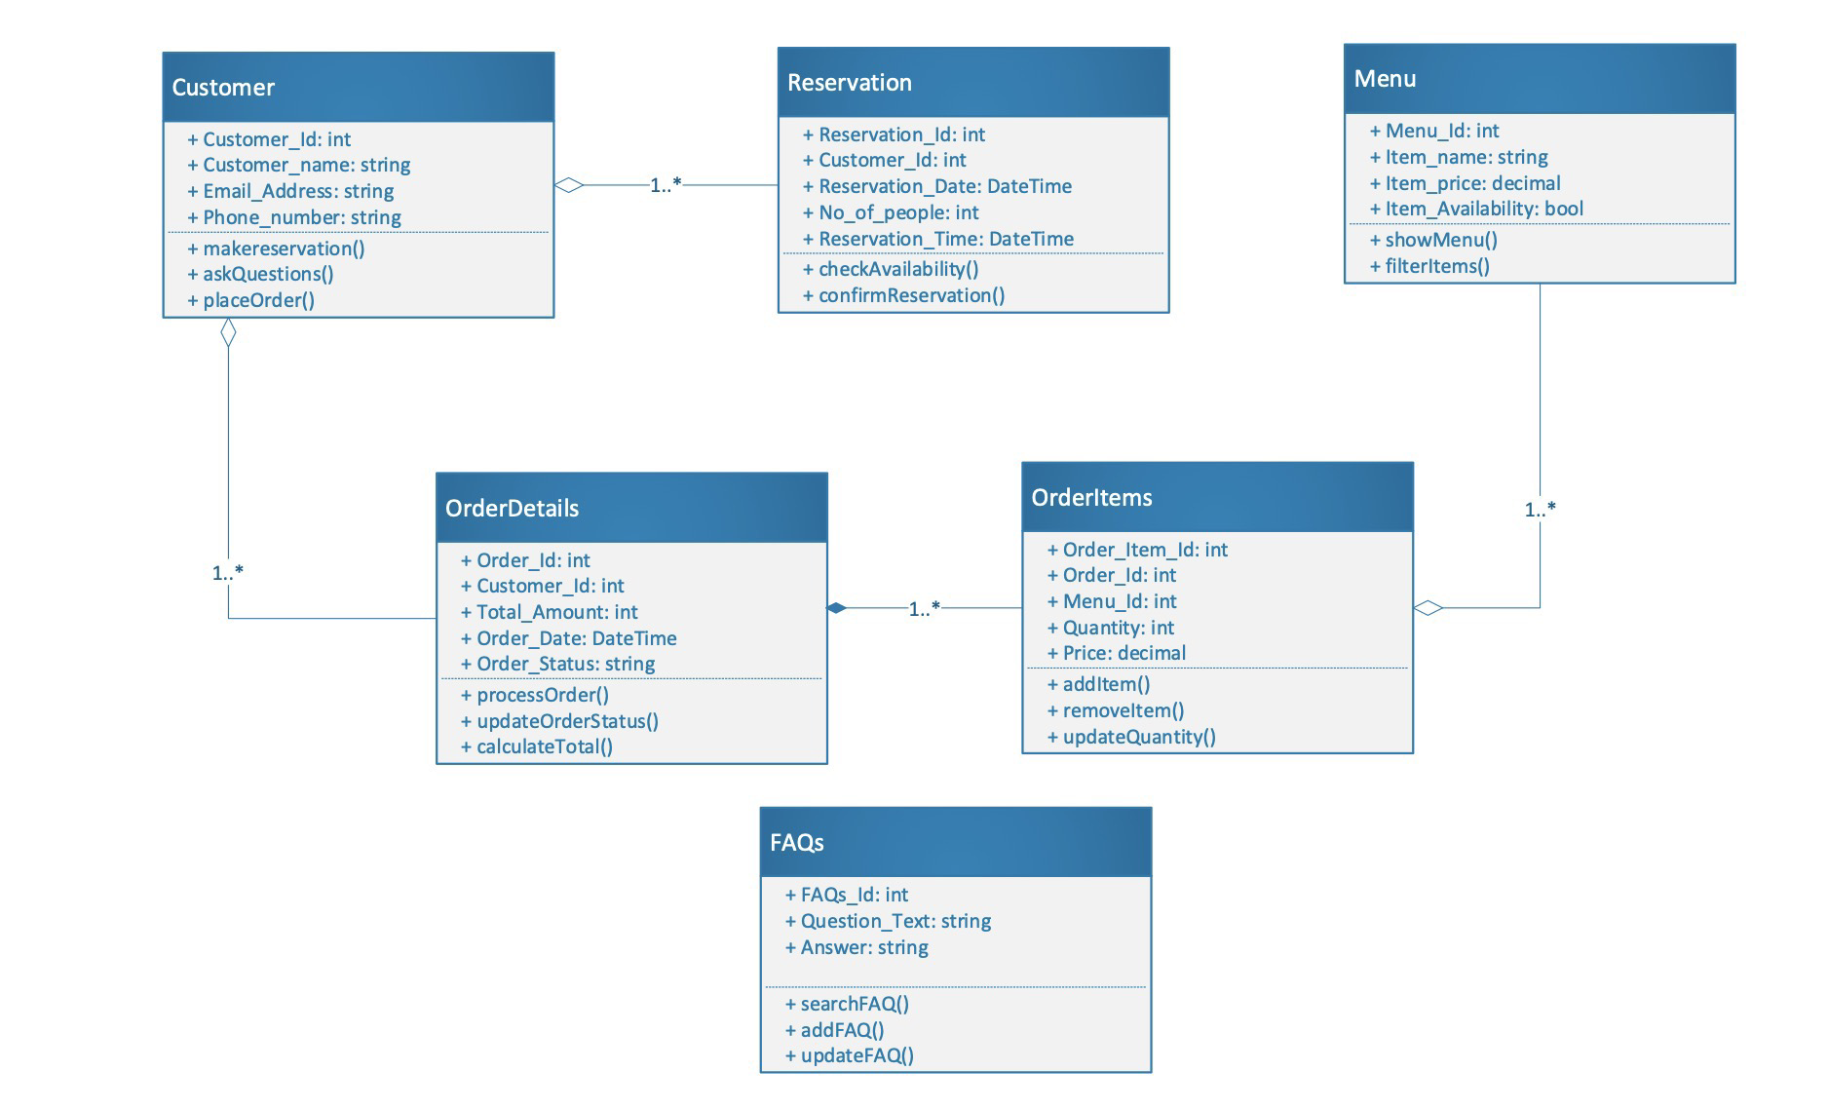

  - Database Model (Database Diagram)

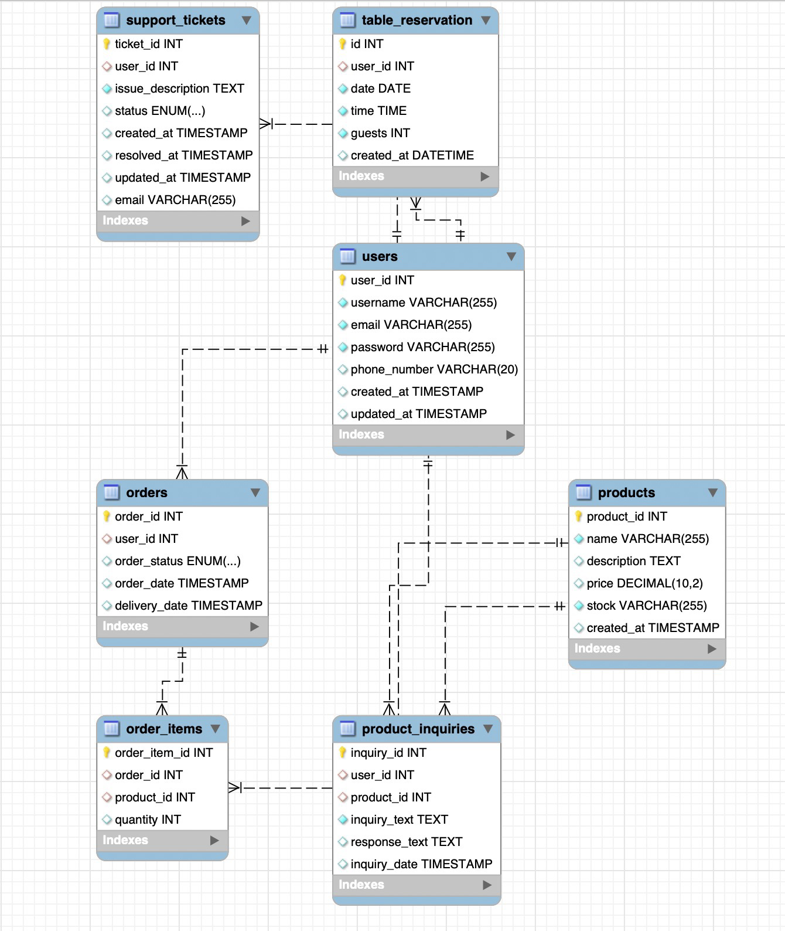

  - Graphical User Interfaces

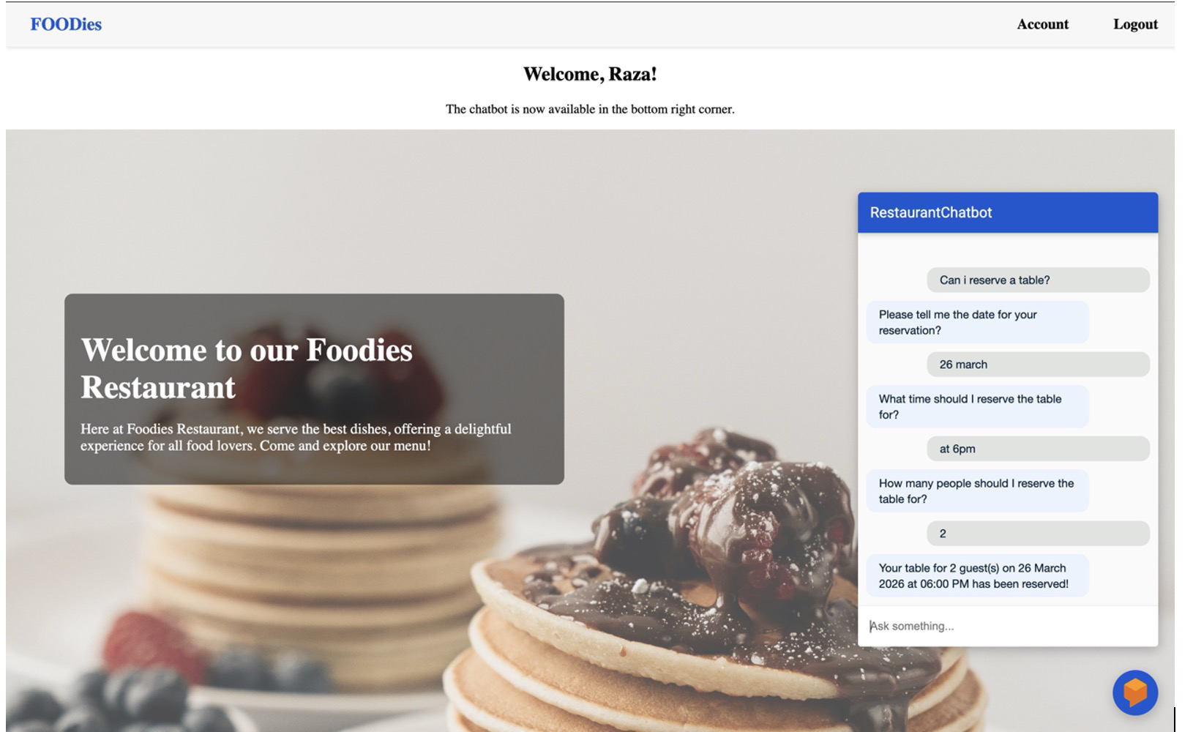

CHAPTER 4
Development

Chapter no.4
DEvelopment 13

4.1 Development plan (Architecture Diagram)

Development Plan (Architecture Diagram)
The development of the chatbot system is planned using a modular architecture where each component works independently but communicates effectively with others. This architecture ensures smooth functionality, easy updates, and better maintenance.
The system is made up of the following main components:
- User Interface (Frontend):
The chatbot is embedded in a web page using HTML, CSS, and JavaScript. This is where the user types messages and views replies from the chatbot.
- Dialogflow (NLP Engine):
This is the core of the chatbot. Dialogflow handles user messages, detects intents (what the user wants), and manages the conversation flow. It also connects to external services through webhooks.
- Webhook (Backend Server):
The webhook is a server-side script written in Python or PHP. It receives data from Dialogflow and processes logic such as booking a table or checking item availability. It also connects to the database.
- MySQL Database:
All important data like reservations, menu items, and user details are stored here. The webhook sends and retrieves data from this database.

REFERENCES

- Virtual university of Pakistan handout CS504

- Virtual university of Pakistan handout CS403

- YouTube.

APPENDIX

